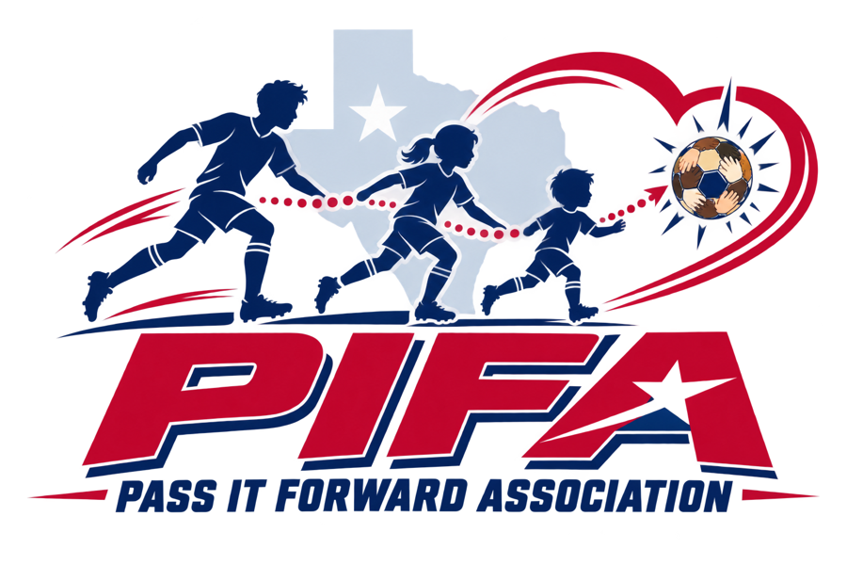
PASS IT FORWARD ASSOCIATION
Player Scholarship Application
Soccer registration, equipment, and free clinics for Johnson County families
Pass It Forward Association (PIFA) is a nonprofit in Cleburne, Texas. Our mission is to remove every financial barrier that keeps children from low-income families from playing, learning, and growing through soccer. One application covers every child in your household.
What PIFA can cover
- Season registration fees. PIFA pays the league directly for full or partial scholarships. We never send cash to families.
- A player kit: cleats, shin guards, socks, a ball, and a water bottle.
- Free skills clinics and help with rides when available.
Who can apply
Children and teens ages [4] to [18] who live in Johnson County or play in a partner league. Your family qualifies in one of three ways:
1. Automatic | Your child gets free or reduced-price school meals, or your family receives SNAP, Medicaid, CHIP, or WIC.
2. Income | Your total household income is at or below the amount in the table below.
3. Hardship | Job loss, medical emergency, foster or kinship care, or another hard situation. Tell us in a few sentences.

Income limits (200% of the 2026 federal poverty guidelines)
People in household | 1 | 2 | 3 | 4 | 5 | 6 | 7 | 8
Yearly income | $31,920 | $43,280 | $54,640 | $66,000 | $77,360 | $88,720 | $100,080 | $111,440
Monthly income | $2,660 | $3,607 | $4,553 | $5,500 | $6,447 | $7,393 | $8,340 | $9,287
More than 8 people: add $11,360 a year ($947 a month) for each additional person. Source: U.S. Department of Health and Human Services, 2026 Poverty Guidelines. PIFA updates this table each year.
How to apply
- Fill out pages 2 to 6 and sign where marked. Page 4 is needed for each player.
- Show proof for Option 1 (a school meal letter or benefits card). We look at it and hand it back; we do not need to keep a copy. Options 2 and 3 need only your signed statement, though we may ask to check a small number of applications.
- Return it to a PIFA volunteer, at a sign-up event, by mail to PIFA, 305 N 2nd St, Godley, TX 76044, or by email or text photo to daniel@passitforwardassociation.org / 817.648.2393. Online: passitforwardassociation.org.
- Deadlines: fall season, [July 15]; spring season, [January 31]. Apply early. Scholarships are awarded in the order complete applications arrive, as funds allow.
Our promise to your family
- Private. Your income and benefit information is seen only by the PIFA Program Director and one trained backup. It is used only to decide scholarships and is never sold or shared, except that we tell your league that your child's fee is covered.
- Respectful. PIFA does not ask for Social Security numbers or immigration status. We serve every eligible family without regard to race, color, national origin, ethnicity, religion, sex, disability, or immigration status.
- Safe. Every PIFA coach and volunteer who works with children passes a background check and abuse-prevention training first.

Questions? Call or text 817.648.2393, or email daniel@passitforwardassociation.org. Se habla español. This form is also available in Spanish.
PASS IT FORWARD ASSOCIATION
Part A. Family Information
Parent or guardian name |  | Relationship to player(s)
Street address |  | ZIP code
City |  | Best phone
Email (optional) |  | OK to text? | ☐ Yes ☐ No

Second parent or guardian (optional) |  | Phone

Preferred language for calls and messages: ☐ English ☐ Spanish ☐ Other: ____________
How did you hear about PIFA? ☐ School ☐ Church ☐ League or coach ☐ Friend or family ☐ Social media ☐ Other: ____________
Part B. Players applying (one line per child)
# | Player full name | Date of birth | Boy / Girl | School and grade | League and team (if known) | New to soccer?
1
2
3
4

Part C. What help does each player need?
# | Registration fee | Cleats (shoe size) | Shin guards | Jersey / shirt size | Free clinics | Help with rides
1
2
3
4

Shirt sizes: YS, YM, YL, AS, AM, AL. Write the size in the box, or check the box if the player needs that item.
Season applying for: ☐ Fall [2027] ☐ Spring [2027] ☐ Both ☐ Clinics only
PASS IT FORWARD ASSOCIATION
Part D. How does your family qualify? (Choose one)
Option 1: Automatic qualification
Check every program that applies. Bring the letter or card when you turn in this form.
☐ Free or reduced-price school meals (school: ______________________)
☐ SNAP (food benefits / Lone Star Card)
☐ Medicaid or CHIP (for the child or family)
☐ WIC
Option 2: Household income
Count everyone who lives in your home and shares income and expenses. Include wages, tips, self-employment, child support, unemployment, Social Security, disability, and other regular income, before taxes.
Number of people in household |  | Total household income | $

Income is for: ☐ a month ☐ a year
Option 3: Hardship
Tell us briefly what is happening (for example, job loss, medical emergency, foster or kinship care, disaster, or another situation). The Program Director reviews each request.

Part E. Family certification
- The information in this application is true and complete to the best of my knowledge.
- I understand PIFA may ask to verify my information, and that a scholarship may be canceled if the information is not true.
- I agree that PIFA may tell my child's league or team that the registration fee is covered, and share my child's name, date of birth, and age group with that league so they can be registered. No financial details will be shared.
- I understand that scholarships are paid to the league or vendor, not to me, and depend on available funds.

Parent / guardian signature |  | Date

PASS IT FORWARD ASSOCIATION
Player Medical and Emergency Form
Complete one page for each player. Make extra copies as needed. Coaches keep this information private and use it only in an emergency.
Player name |  | Date of birth

Emergency contacts (other than the parent on page 2)
Name | Relationship | Phone | Can pick up player?

Health information
Allergies (food, insect stings, medicine)
Medical conditions (asthma, diabetes, seizures, heart, other)
Medicines the player carries (inhaler, EpiPen, other)
Doctor or clinic name and phone
Health coverage (optional) | ☐ Medicaid ☐ CHIP ☐ Private insurance ☐ None ☐ Prefer not to say

Consent for emergency medical care
If my child is hurt or becomes ill during a PIFA activity and I cannot be reached right away, I authorize PIFA coaches and volunteers to call 911 and to seek and consent to emergency medical treatment for my child from licensed medical providers. I understand PIFA will try to reach me as quickly as possible. PIFA is not responsible for medical bills.
- Concussions: a player with any sign of a head injury will be removed from play and will not return until a licensed health care provider gives written clearance.
- Heat: players should bring water to every practice and game. Coaches give regular water breaks and adjust activity in extreme heat.

Parent / guardian signature |  | Date

PASS IT FORWARD ASSOCIATION
Part F. Safety, Conduct, and Participation Agreement
How PIFA keeps children safe
- Every coach and volunteer who works with children passes a background check and abuse-prevention training before working with players.
- At least two cleared adults are present whenever adults are with players. No adult should be alone with a child who is not their own.
- Adults do not send private one-to-one messages to players. Team messages go to parents or to a group that includes a parent or second adult.
- PIFA volunteers do not drive players other than their own children unless PIFA's transportation policy and your written permission allow it.
- Report any concern to the PIFA Safeguarding Officer at 817.648.2393 or daniel@passitforwardassociation.org. If you think a child is being abused or neglected, call the Texas Abuse Hotline at 1-800-252-5400 or 911 in an emergency.
Player promise
I will try my best, listen to my coaches, respect my teammates, opponents, and referees, and tell a trusted adult if anything makes me feel unsafe.
Parent promise
- Get my child to practices and games on time, or tell the coach ahead of time if they cannot attend.
- Cheer in a positive way and treat coaches, referees, and other families with respect.
- Follow the rules of my child's league, and tell PIFA if our contact information changes or my child stops playing, so the spot can go to another child.

ASSUMPTION OF RISK AND RELEASE (PLEASE READ CAREFULLY)
I UNDERSTAND THAT SOCCER IS A PHYSICAL SPORT AND THAT PARTICIPATING IN PIFA PRACTICES, CLINICS, GAMES, AND EVENTS INVOLVES RISKS, INCLUDING FALLS, COLLISIONS, SPRAINS, BROKEN BONES, CONCUSSIONS, HEAT ILLNESS, AND IN RARE CASES SERIOUS INJURY. I VOLUNTARILY ALLOW MY CHILD TO PARTICIPATE AND ACCEPT THESE RISKS.
TO THE FULLEST EXTENT ALLOWED BY TEXAS LAW, I RELEASE PASS IT FORWARD ASSOCIATION AND ITS DIRECTORS, OFFICERS, COACHES, VOLUNTEERS, AND PARTNERS FROM ANY CLAIMS I HAVE FOR INJURY, ILLNESS, OR PROPERTY LOSS ARISING FROM MY CHILD'S PARTICIPATION, INCLUDING CLAIMS BASED ON THEIR OWN NEGLIGENCE. THIS RELEASE DOES NOT APPLY TO GROSS NEGLIGENCE OR INTENTIONAL MISCONDUCT.
MY CHILD'S LEAGUE MAY ALSO REQUIRE ITS OWN REGISTRATION WAIVER.

Parent / guardian signature |  | Date

Player signature (age 10 and up) |  | Date

PASS IT FORWARD ASSOCIATION
Part G. Photo and Story Permission (optional)
PIFA shares photos and stories to thank donors and raise money for more scholarships. We will not use your child's name, photo, or story without your permission. Saying no does not affect your scholarship in any way.

☐ Yes, PIFA may use team or action photos of my child, with no name shown.
☐ Yes, PIFA may use photos of my child with their first name only.
☐ Yes, PIFA may contact me about sharing our family's story. I will approve the words before they are used.
☐ No, please do not use photos of my child.

Players covered by this choice: ___________________________________________ You may change your choice at any time by contacting PIFA.

Parent / guardian signature |  | Date

Before you turn this in, check that you have:
☐ Filled out Parts A, B, and C (page 2)
☐ Chosen one way to qualify and signed Part E (page 3)
☐ Completed a Medical and Emergency Form for each player (page 4)
☐ Signed Part F (page 5) and, if you wish, Part G (this page)
☐ Brought your school meal letter or benefits card, if you chose Option 1

Thank you. A PIFA volunteer will contact you within [10] days.
PASS IT FORWARD ASSOCIATION
FOR PIFA OFFICE USE ONLY
Detach this page and keep it with the confidential eligibility file. Only the Program Director and the designated backup may see financial information (Bylaws, Section 8.2).
Date received |  | Received by
Application complete? | ☐ Yes ☐ No, missing: | Language | ☐ English ☐ Spanish

Eligibility: ☐ Option 1, document viewed (type: ____________ , not copied) ☐ Option 2, at or below 200% FPL ☐ Option 3, hardship approved ☐ Not eligible

# | Player | Award | Amount | Paid to (league / vendor) | Date paid | Kit given
1
2
3
4
5

Award codes: F = full scholarship, P = partial scholarship, K = kit only, C = clinics only

Program Director |  | Date

Spot-check selected?: ☐ Yes / Sí ☐ No

Retention: keep eligibility records under the document retention policy, then destroy them securely (Bylaws, Section 13.3). Do not store income details in the team roster or the general donor database.

